Supplementary Materials (1. Methods; 2.Tables; 3. Figures) for “The impact of projected increases in urbanization on ecosystem services”

1. Supplementary Methods

a) The Grid-to-Grid hydrological model

The work presented here uses a single hydrological model (Grid-to-Grid, or G2G) and set of parameters to simulate river flows for the whole of Britain. The model uses digital datasets of terrain, soil and urban land-cover to provide the spatial information needed to simulate spatial differences in the response of a catchment to rainfall. Model output consists of a (1 x 1 km) grid of river flow estimates across the region of application. By way of illustration, Fig. S1 shows the median annual maximum flow across Britain (peak flow at the two-year return period).

The G2G model is modular in form and distinguishes between runoff-production and lateral routing of runoff to form river flow. The runoff-production scheme divides the terrain into a square grid of vertical soil columns which are subject to precipitation and evaporation as indicated in Figure S2. Some of the rainwater entering the column is stored in the soil, some can drain laterally to adjacent grid-squares, and saturation-excess flow contributes to surface runoff. Water also moves downwards via percolation and drainage which eventually contributes to groundwater (sub-surface) flow. Digital datasets are used to configure and parameterise lateral routing of runoff across the landscape to form estimates of river flow. Flow-routing is undertaken in two parallel planes representing sub-surface and surface pathways with a return flow term representing the contribution of groundwater to river flows (Fig. S2).

The G2G model is used here as an area-wide model providing flow estimates over a large region, although it can be calibrated specifically to optimise performance for a particular catchment. As an area-wide model, the G2G can be less accurate for a particular catchment than a model specifically calibrated to the catchment, but is well suited to support river flow simulation at any set of locations within a region. Bell et al. (2009) assessed the G2G model performance for 43 British locations using daily rainfall and flow observations and found that it provided reasonably good daily flow estimates for catchments all across Britain, particularly those catchments where the response to rainfall is relatively free from artificial influences (e.g. abstractions, discharges).

The link between changes in many types of land cover and changes to flood risk is very difficult to quantify (O’Connell et al. 2007), with the possible exception of urban development. Urbanization has the effect of covering areas of land with surfaces impervious to water, such as roofs, roads and car-parks, and the proportion of an area that is impervious can be linked to population density (e.g. Stankowski, 1972). Soil storage and infiltration capacity are greatly reduced in urban developments, leading to higher volumes of surface runoff produced when it rains, and a much faster and higher flow peak in the rivers to which urban areas drain. Although these effects are well documented and understood, there have been few attempts to generalise them for use in ungauged catchments, and although detailed localised studies exist, “the results are not generally transferable between catchments” (Kjeldsen, 2009). In large-area applications where an estimate of the effect of urban development on river flows is required, relatively simple enhancements are made to hydrological models. For example, in the UK’s Flood Estimation Handbook (FEH: Institute of Hydrology, 1999), the percentage of runoff from the impervious fraction of a catchment is higher (between 60 and 90% of rainfall) than for the non-urbanised fraction. In the FEH, the impervious catchment fraction is derived from spatial datasets of urban and suburban landcover which are combined to derive a composite index. This index quantifies “urban extent” by summing the urban and suburban elements in a catchment and weighting suburban areas by a factor of 0.5; a pragmatic choice based on the assumption that in the UK, half of suburban development is assumed to be urban and the other half is vegetation.

The G2G urban module adopts a similar approach to the FEH, but the method has been modified to take into account the gridded, physically-based configuration of the G2G, instead of the catchment-based approach used by the FEH. Specifically, for G2G grid-cells containing significant urban and suburban areas (defined by the LCM2000 spatial dataset of land-cover, Fuller et al., 2002), the soil storage is reduced by the factor 1-0.7φ_{u}-0.3 φ_{s} where φ_{u} and φ_{s} are the fractions of urban and suburban area within each grid cell. This reduction in soil storage will have the effect of increasing runoff, particularly surface runoff, in urban areas leading to a faster response to rainfall. The responsiveness of the catchment to rainfall in urban areas has been further enhanced by increasing the routing speed in rivers by a factor of 2 for grid-cells where the fraction of urban area, φ_{u}>0.25. The scheme has been developed and assessed on a range of catchments across the UK (Bell et al. 2009) and has been found to give sensible results. However it is important to note that the flow regime in heavily urbanised catchments can also be affected by other artificial influences such as groundwater abstraction or effluent returns, processes which are not currently represented in the G2G model.

We quantified loss of flood mitigation by calculating the percentage increase in peak flow at the two year return period. Preliminary analyses showed that using a 20 year return period rather than a two year return did not qualitatively affect our findings: For the densification scenario, 1,736,000 people were projected to reside within 1 x 1 km squares which have at least 10 % projected increases in peak flows at the 2 year return period; this decreased to 1,644,000 people when we used the 20 year return period. For the sprawl scenario, 11,000 people were projected to reside within 1 x 1 km squares which have at least 10 % projected increases in peak flows at the 2 year return period; this increased to 15,000 people when we used the 20 year return period.

b) Calculation of Agricultural Production (as per Anderson et al. 2009)

We obtained detailed information on the land area covered by major crops and number of livestock for Britain from the June Agricultural Survey for England (DEFRA 2004), Wales (Welsh Assembly Government 2006) and Scotland (SEERAD 2006). The June Agricultural Survey is a randomly stratified survey (30% of farms in England) that is spatially explicit at the ward/local authority level. We obtained boundary layers for these areas from UKBorders (http://www.edina.ac.uk/ukborders/) and SEERAD. We then calculated the agricultural land area of each ward (cropland plus pastures and any grassland, including rough grazing and calcareous grassland) based on the Land Cover Map 2000 (Fuller et al. 2002). We converted the area of a crop/number of livestock in the agricultural land of each ward into gross margins by multiplying them by gross margin per unit area (or per unit of livestock) as obtained from the Farm Management Handbook (FMH) 2007/2008 (Beaton et al. 2007) (Table S1). If more than one estimate of gross margin per unit area was given, we used the intermediate value or the average of the high and low value. The gross margin accounts for variable costs of production. We excluded subsidies from the gross margin per unit area by removing the decoupled single payment subsidy (‘all other output’ in the FMH) from the output based on whole farm data for either cereal, horticulture, dairy, lowland cattle and sheep or ‘less favoured areas’ (LFA) cattle and sheep farms.

We calculated separate gross margins for the lowlands and LFA areas for cows and sheep to account for the two estimates of gross margins per livestock unit present in the FMH. We clipped the agricultural census layer by a layer delineating least favoured areas obtained from www.magic.gov.uk. If a ward contained both less favoured areas and lowlands, we divided the number of cattle and sheep between the less favoured areas and lowlands based on the percentage of the ward that was located in each area. We did not calculate gross margins for hay and other crops raised to feed livestock as we assumed these would be included as variable costs for livestock. We also did not include poultry or pigs in our estimates as both are largely produced in factory farms which are largely disconnected from inputs from the land on which they occur.

c) Calculation of Stored Carbon (as per Anderson et al. 2009)

The carbon storage layer is an estimate of combined organic soil and above ground vegetation carbon (in kg C) calculated at the 1 km x 1 km grid resolution. We obtained vegetation carbon data at the 1 km x 1 km grid resolution from the Centre for Ecology & Hydrology (Milne & Brown 1997). Soil parameter, land use and soil series data were obtained from the National Soil Resources Institute (NSRI) for the top 1 m of soil (to bedrock or 1 m depth, whichever was less) which enabled us to calculate soil carbon density at the 1 km x 1 km grid resolution in two steps. First, we calculated the soil organic carbon density values for each of the 977 soil series in Britain based on their percent soil organic carbon, bulk density and stoniness. Secondly, we calculated the average soil organic carbon density per 1 km grid cell based on this soil series and land use data. The latter calculation was done as a weighted average based on the five dominant land uses (Wood, Semi natural, Grassland, Arable and Garden). Estimates for areas with no specified soil carbon content (e.g. towns, roads etc. or soil series with unknown carbon content) were obtained from the area weighted average of specified carbon densities of land use and soil series combinations within each grid cell. This may lead to a slight overestimation of soil carbon within built up areas and roads. However, as urban areas already have the lowest carbon levels in England in this layer, this potential bias will have very little effect on the results. In addition, the soil depth of the NSRI soil C dataset is limited to 1 m depth, thus peatland C stocks will be underestimated in deep peat (i.e. > 1 m) areas. However, the exact extent of those deep peat areas is currently unknown. This limitation of the dataset does increase regionally specific (peat) C stock uncertainties, but will have little or no effect on the England-wide patterns of carbon storage, as this uncertainty will not affect the relative importance of regions with predominantly mineral vs. organic peat soils.

We then calculated the average carbon density per 1 km x 1 km grid cell by adding the soil organic carbon and vegetation carbon grids together. This grid was then spatially delineated using GIS to include only the land area of Britain as described earlier.

d) Description of urbanization model

We mapped projected changes in dense urban and suburban land cover based on regionally resolved projections of the change in the human population of Britain between 2006 and 2031. We modelled two extremes of changes in urbanization based on 1) future population growth preferentially occurring at low housing densities - hereafter the ‘sprawl’ scenario; and 2) future population growth preferentially occurring through densification of existing urban areas (conversion of suburban areas to dense urban areas) – hereafter the ‘densification’ scenario.

We also re-ran both the ‘sprawl’ and ‘densification’ scenario to minimize losses of stored carbon and agricultural production, respectively.

Our urbanization model is unusual in that we are 1) attempting to model urban growth across a very large area and 2) linking our growth into unusually detailed (local authority/ward level ~= counties in the US) population projections; and 3) needed to provide output that could be used in our published hydrological model (Bell et al. 2009). Urbanization models created by social geographers (e.g. Wu & Martin 2002) and economists (e.g. Spivey 2008) focus on specific cities or regions and not large areas such as Britain. Models of future land use change do exist for Britain, but even the most spatially resolved of these (Verburg et al. 2008) does not give the percentage of each 1 x 1 km grid square that is covered by dense urban and suburban land cover that our hydrological model (Bell et al. 2009) required. Note that only having two land cover types – urban and suburban to represent urban areas – is both standard practice (due to limitations on data availability) in land use change research (e.g. Verburg et al. 2008), and represents the best available data for Britain.
The model structure is as follows:

Part 1: Calculation of current population and population density at the 1 x 1 km grid resolution for Britain.
This stage is the same for both the ‘densification’ and ‘sprawl’ scenarios.

Step 1 – Calculate the percentage of each 1 x1 km cell in Britain that is currently classed as dense urban, suburban, and that is suitable for new urbanization.
a. Calculate the percentage of each 1 x 1 km grid cell that is currently dense urban or suburban from the 25 m resolution raster Land Cover 2000 dataset (the best available data) for all of Britain.
b. Calculate the percentage of each 1 x 1 km cell in Britain that is suitable for new urbanization. We considered the following not to be suitable for new urbanization: existing urbanization, water, wetland, coastal rock, submerged rock and montane areas (based on the LCM 2000). We also excluded all areas covered by statutory protected areas for biodiversity (e.g. SSSI’s) (Jackson & Gaston 2008), National Parks, listed landscapes, parks, gardens and monuments (all from English Heritage and their Scottish and Welsh counterparts), as all these areas are protected from land use change by UK law. These areas include well-known urban parks such as London’s Regents Park.

Step 2 – Calculation of the current (2006) population density in urban and suburban areas for each district in Britain.
a. Calculate the area covered by dense urban and suburban land in each district by multiplying the percentage of each in each 1 x 1 km cell by the land area of the cell and summing up across the district.
b. Calculate the population density in dense urban and suburban areas by dividing the population of the district by the dense urban land area plus the suburban land area, after multiplying the suburban area by 0.65 to account for the lower density in suburban areas. We obtained the value of 0.65 by calculating the average population density of dense urban and suburban areas in England (~85% of British population) at the 1 x 1 km resolution using modelled data from the last available census (2000). Population modelling was done using the “SurfaceBuilder software (Martin 2005). Note that while we assume that the ratio of dense urban to suburban population density remains constant for all districts, the actual densities are district-specific.

Step 3 - Calculate the increase in population (2006-2031) for each district. This is the National Statistics projected population for 2031 minus the population in 2006. As we assumed no decrease in urbanization, we set the change in population to 0 for the districts projected to have negative growth in 2031.

Part 2: Calculate the increase in urban and suburban area for Britain. This stage is different for the ‘sprawl’ and ‘densification” scenarios.

Part 2A: “Sprawl” scenario – assumes that projected population growth will be placed in new, suburban housing where possible (suitable areas in squares that are less than 90% urbanized), with densification (the conversion of suburban to dense urban land cover) a last resort.

Step 1 – Create new suburban areas. This is calculated at the district level for each district in Britain. New suburban areas are preferentially located near existing urban areas within 1 x 1 km grid cells that are already heavily urbanized, as new urbanization in Britain tends to occur in/near existing urban areas (Bibby 2009); it is assumed that most new housing will occur in these areas as well (Entec 2004).

a. Select all 1 x 1 km cells that are located near (within 1 km) cells that are covered by 50% or more urban or suburban areas that have some land remaining that is suitable for new urbanization. Exclude cells that are over 90% urbanized (dense urban + suburban), on the assumption that urban planners will attempt to retain some green space for recreation. Sort these cells from most urbanized to least urbanized (dense urban + suburban).

b. Assign a portion of the projected change in population of the district to the most urbanized cell, and convert areas suitable for new urbanization to suburban. The increase in suburban for the cell is determined by the amount of land in the cell where urbanization is possible (provided they are not already 90% or more urbanized), the population density of existing suburban areas in the district (calculated in Part 1) and the amount of population left to add (growth 2006-2031). For example, if 25% of a cell is suitable for urban growth and all of the cell is land, then you have 0.25 km² available for new suburban growth. If the density of existing suburban areas in the district is 4000 people/km², then 1000 new people can be placed into the square. If the projected growth for the district is projected to be 10,000 people, then 1/10th of this future population is assigned to the cell. If the projected growth for this district is only 500, then all projected growth for the district is assigned to this first cell, and only half the suitable land (0.125 km²) becomes ‘suburban’.

c. Select the next most urbanized cell in (a) and repeat step (b) until either the end of the list (a) or until there is no projected population growth left to assign.

d. If there is still projected population growth left to assign, select all remaining 1 x 1 km cells in the district that are located within 2 km of cells that are covered by 50% or more dense urban or suburban areas and have at least some land suitable for urbanization. Exclude cells that are over 90% urbanized, on the assumption that urban planners will attempt to retain some green space for recreation. Sort these cells from most to least urbanized, and repeats steps b & c.

Step 2 – Convert existing suburban areas to dense urban (densification). Step 2 is only run if there is still projected population growth to assign in a given district after step 1. We assume that densification preferentially occurs in the cells that have the highest percentage of existing urbanization.

a. Select all 1 x 1 km cells that have at least some suburban areas, and that are at least 50% dense urban or suburban. Sort these cells from most urbanized to least urbanized.

b. Assign a portion of the projected change in population of the district to the most urbanized cell, and convert suburban areas to dense urban areas (densification). The amount of densification is determined by the amount of suburban land, the population density of existing urban areas in the district (calculated in Part 1) and the amount of population left to add. For example, if 25% of a cell is suburban (0.25 km² if the cell is entirely land), then this 0.25 km² of suburban land can be converted to urban land cover. If the density of existing urban areas in the district is 1000 people/km², then 1000 * 0.25 *(1 - 0.65) = 88 new people can be accommodated by this densification, assuming that the density of suburban areas is 65% of dense urban areas, as discussed in Part 1.

c. Select the next most urbanized cell in (a) and repeat step (b) until either the end of the list (a) or until there is no projected population growth left to assign.

Part 2B: “Densification” scenario – assumes that projected population growth will preferentially occur through conversion of suburban to dense urban land cover (densification), with new housing only created once all suburban areas are converted to dense urban. Also, under this scenario we assume that any new housing will occur at dense urban, rather than suburban, population densities.

Step 1 – Convert existing suburban areas to dense urban (densification). This is exactly the same as Step 2 in the “Sprawl” scenario (Part 2A).

Step 2 – Create new dense urban areas. This is the same as Step 1 in the “Sprawl” scenario, except that new housing is created at dense urban and not suburban population densities (as calculated in Part 1).

Part 2C: Minimizing losses of stored carbon and agricultural production
The methodology we used to minimize losses of stored carbon or agricultural production was to sort all squares in a district which were suitable for new housing within 1 km (or 2km – see Part 2A - Step 2 part d) of existing urban areas (50% or more urban) not by the amount of existing urbanization in them (the default scenario), but rather by the amount of stored carbon or agricultural production present in the square. We then preferentially place new urban (suburban under the ‘sprawl’ scenario (Part 2A – Step 1); dense urban under the ‘densification’ scenario (Part 2B-Step2)) in the squares with the lowest amount of stored carbon or agricultural production, respectively, in the district. Note that new urban housing is still being placed near (within 1 or 2 km) of existing urban areas (the urban fringe), as this is where it is generally assumed that most new house building will take place (Entec 2004).

Procedures to minimize the loss of flood mitigation services in addition to stored carbon or agricultural production have not been investigated here, as analyses of this type are a research topic to themselves. Experiments of this nature might best be undertaken at a local/catchment scale for which a fuller understanding of local urban hydrological processes is available. However, use of Sustainable Urban Drainage Systems in new urban areas could potentially reduce the impact of both urban and suburban developments on downstream flood risk.

f) Post-hoc very high density urbanization scenario

We ran a third urbanization scenario in which we assumed that future population growth would preferentially occur by increasing the population density of suburban and dense urban areas to be 50% greater than the current density of dense urban areas by 50%. Under this scenario, only 56 km² of land (0.0002 % of Britain) would need to be converted to new urban areas (vs 948 km² and 3302 km² under the densification and sprawl scenarios, respectively), so losses of agricultural production and stored carbon would be extremely small. However, we had insufficient data to reliably model the effects of such increases in density on changes in flood risk in our hydrological model.

Part 2D: “Densification plus” scenario – assumes that projected population growth will preferentially occur through increasing the population density in existing high density housing by up to 50%, followed by conversion of suburban to dense urban land cover (again, allowing 50% higher population densities than in current dense urban land cover, with new housing only created once all suburban areas are converted to dense urban. Also, under this scenario we assume that any new housing will occur at dense urban (at 50% higher population densities), rather than suburban, population densities.

Step 1 – Increase the density of existing dense urban areas by up to 50%. As in the other scenarios, density is calculated at the local authority/ward level. The steps here are as follows:

a. Select all 1 x 1 km cells that have at least some urban areas, and that are at least 50% dense urban or suburban. Sort these cells from those with the most dense urban to the least dense urban land cover.

b. Assign a portion of the projected change in population of the district to the cell with the most dense urban land cover, and increase the population density by up to 50%. The number of people (portion of the projected population growth) that can be assigned to the cell is determined by the amount of urban land, the population density of existing urban areas in the district (as described in Part 2A) and the amount of population left to add. For example, if 25% of a cell is dense urban (0.25 km² if the cell is entirely land), then this 0.25 km² of urban land can be densified. If the density of existing urban areas in the district is 1000 people/km², then 1000 * 0.25 *0.5 = 125 new people can be accommodated by this increase in the population density of the dense urban areas.

c. Select the next most urbanized cell in (a) and repeat step (b) until either the end of the list (a) or until there is no projected population growth left to assign.

Step 2 – Convert existing suburban areas to dense urban (densification). This is exactly the same as Step 1 in the “Densification” scenario (Part 2B), except that population density can now increase 85%, rather than 35% as in the standard ‘Densification’ scenario. For example, if 25% of a cell is suburban (0.25 km² if the cell is entirely land), then this 0.25 km² of suburban land can be converted to urban land cover. If the density of existing urban areas in the district is 1000 people/km², then 1000 * 0.25 *(1 - 0.15) = 212 new people can be accommodated by this densification, assuming that the density of suburban areas is 65% of existing dense urban areas, and that there is an additional increase of 50%,

Step 3 – Create new dense urban areas (again, allowing for a 50% increase in density). This is the same as Step 1 in the “Sprawl” scenario, except that new housing is created at dense urban (allowing for a 50% increase in density) and not suburban population densities.

f) Calculation of Carbon Emissions caused by loss of 1% of UK carbon stock

The total stock of stored carbon (above and below-ground) in Britain (cf. Anderson et al. 2009) is 5,623.9 million tonnes. A loss of 0.7% of this amount (the projected loss under the ‘sprawl’ scenario by 2031) is therefore 39.4 million tonnes of carbon. This translates into 105 million tonnes of CO₂ (39.4 * 2.667, given that the atomic weight of carbon is 12 and the atomic weight of CO₂ is 44). The total UK carbon emissions in 2008 were 626.0 million tonnes of CO₂-equivalent (DECC2010), so a loss of 105 million tonnes of CO₂ translates to 16.8% of the 2008 total.

g) Calculation of Agricultural production and self-sufficiency

The total value of agricultural production in Britain was 2006 was £5.310 billion. A reduction of 1.1% production (the projected loss under the ‘sprawl’ scenario) is therefore about £58 million.

The UK was 58% self-sufficient in food production (DEFRA 2007) in 2006. Given that the population of Britain is projected to increase by 16% from 58,837,000 in 2006 to 69,172,000 in 2031, a 16% increase in agricultural production would be needed to maintain 2006 levels of self-sufficiency. A 1.1% decrease in production would therefore result in self-sufficiency to decrease to ~48%.

References

Anderson, B. J., Armsworth, P. R., Eigenbrod, F., Thomas, C. D., Gillings, S., Heinemeyer, A., Roy, D. B. & Gaston, K. J. 2009 Spatial covariance between biodiversity and other ecosystem service priorities. Journal of Applied Ecology 46, 888-896.
Beaton, C., Catto, J. & Kerr, G. (ed.) 2007 The farm management handbook 2007/2008. Edinburgh, UK: Scottish Agricultural College.
Bell, V.A., Kay, A.L., Jones, R.G., Moore, R.J., Reynard, N.S., 2009. Use of soil data in a grid-based hydrological model to estimate spatial variation in changing flood risk across the UK. Journal of Hydrology 377, 335-350.
Bibby, P. 2009 Land use change in Britain. Land Use Policy 26, S2-S13.
DECC. 2010 Annual statement of emissions for 2008. London: Department of Energy and Climate Change.
DEFRA. 2004 June Agricultural Survey: Department for Environment Food and Rural Affairs.
DEFRA. 2007 Agriculture in the UK 2006: Department for Environment, Food and Rural Affairs.
Entec. 2004 Study into the environmental impacts of increasing the supply of housing in the UK. Northwich, UK: Entec UK Limited.
Fuller, R. M., Smith, G. M., Sanderson, J. M., Hill, R. A. & Thomson, A. G. 2002 The UK Land Cover Map 2000: Construction of a parcel-based vector map from satellite images. Cartographic Journal 39, 15-25.
Institute of Hydrology. 1999. Flood Estimation Handbook. Institute of Hydrology, Wallingford, UK, Vols 1-5.
Jackson, S. F. & Gaston, K. J. 2008 Incorporating private lands in conservation planning: Protected areas in Britain. Ecological Applications 18, 1050-1060.
Kjeldsen, T.R.2009. Modelling the impact of urbanisation on flood runoff volume. Water Management 162, 329-336.
Martin, D. 2005 Surface Builder Version 1.0: Geodata Institute. Available at: http://www2.geog.soton.ac.uk/users/martindj/davehome/software/surfacebuilder/SurfaceBuilder.zip.
Milne, R. & Brown, T. A. 1997 Carbon in the vegetation and soils of Great Britain. Journal of Environmental Management 49, 413 - 433.
O'Connell, E., Ewen, J., O'Donnell, G. and Quinn, P., 2007. Is there a link between agricultural landuse managment and flooding? Hydrology and Earth System Sciences, 11(1), 96-107.
SEERAD. 2006 June Agricultural Survey: Scottish Executive Environment and Rural Affairs Department (SEERAD). .
Spivey, C., 2008. The Mills-Muth model of urban spatial structure: Surviving the test of time? Urban Studies 45, 295-312.
Stankowski, S.J.1972. Population density as an indirect indicator of urban and suburban land-surface modifications. US Geological Survey, Professional Paper 800-B, B219-B224.
Verburg, P.H., Eikhout, B., Meijl, H., 2008. A multi-scale, multi-model approach for analyzing
the future dynamics of European land use. The Annals of Regional Science 42, 57-77.
Welsh Assembly Government. 2006 Agricultural Small Area Statistics.
Wu, F.L., Martin, D., 2002. Urban expansion simulation of Southeast England using population surface modelling and cellular automata. Environment and Planning A 34, 1855-1876.

2. Supplementary Tables

Table S1: Summary of values used in calculating the gross margin of agriculture production (as per Anderson et al. 2009).
Output | Gross margin per unit¹ | Notes
Horticulture | 8627 | Includes fruit, vegetables, hardy stock, nursery, vineyards, flowers
Barley | 205 | Assume 50/50 split between spring and winter barley
Wheat | 354 | Assuming all winter wheat
Potatoes | 1053 | Maincrop ware
Oilseed rape | 20.76 | Assuming all winter rape. Biofuel subsidy removed.
Field beans | -19.31 | Protein crop subsidy removed
Peas for dry  harvesting | -125.31 | Protein crop subsidy removed
Sugar beet | 255
Dairy | 805.30 (£/cow)
Ewe equivalent (LFA) | 21.9 (£/ewe equivalent) | 1 breeding cow = 7.5 ewe equivalent; 1 ewe = 1 ewe equivalent²⁷
Ewe equivalent (lowland) | 34.2 (£/ewe equivalent)
¹Gross margins per unit area in £/ha unless otherwise indicated.

Table S2: Effects of modification of urbanization scenarios to minimize losses of agricultural production or stored carbon on the number of people predicted to be affected by projected increases in peak flows (2 year return periods) under the sprawl and densification scenarios of urban growth. ‘Changes from the base scenario’ are the percentage differences in the population affected between base scenario and either of the minimization scenarios (e.g. 203,000/180,000 = 1.13 = 13% increase in the population affected by at least 50% increases in peak flows under the agricultural loss minimization scenario as under the base scenario).

 |  | Number of people near river - 2031 projections
Loss of agriculture or carbon being minimized? | Threshold percentage increase in peak flow | ---------Densification--------- |  | --------------Sprawl---------------
Loss of agriculture or carbon being minimized? | Threshold percentage increase in peak flow | Population affected | Change from base scenario (%) | Population affected | Change from base scenario(%)
Neither  (base  scenario) | 10% | 1,736,000 | N/A | 11,000 | N/A
Neither  (base  scenario) | 20% | 774,000 | N/A | 1,000 | N/A
Neither  (base  scenario) | 50% | 180,000 | N/A | 0 | N/A
Loss of  Carbon  Storage minimized | 10% | 1,761,000 | + 1% | 14,000 | + 27%
Loss of  Carbon  Storage minimized | 20% | 826,000 | + 7% | 2,000 | + 2%
Loss of  Carbon  Storage minimized | 50% | 178,000 | - 1% | 0 | No change
Loss of  Agricultural  Production  minimized | 10% | 1,776,000 | + 2% | 16,000 | + 45%
Loss of  Agricultural  Production  minimized | 20% | 820,000 | + 6% | 2,000 | + 100%
Loss of  Agricultural  Production  minimized | 50% | 203,000 | + 13% | 0 | No change
3. Supplementary Figures

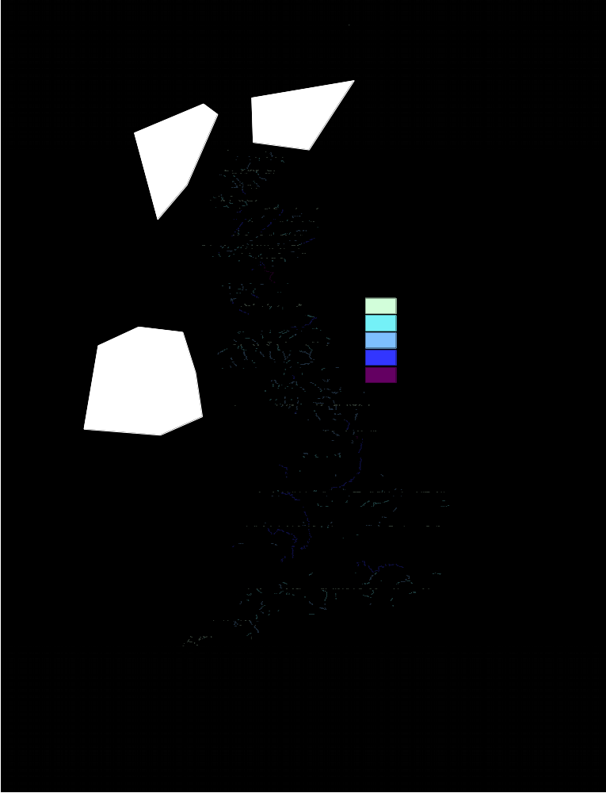
Fig. S1 – Peak flows across Great Britain, highlighting how time-varying G2G model output can be used to provide maps of spatially relevant quantities, in this case, median annual maximum flows (this is also the two year return period).

River
Lateral drainage
Groundwater flow (sub-surface runoff)
Subsurface
flow
Saturation-excess surface runoff
Percolation
Return
flow
River
flow

Figure S2. Schematic of the Grid-to-Grid hydrological model.

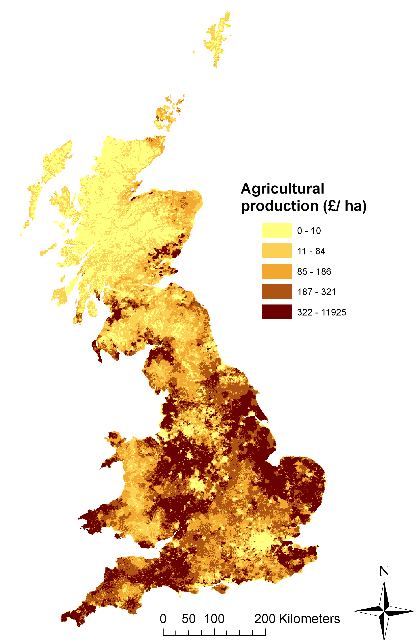
Fig. S3 – Agricultural production at the 1 x 1 km grid resolution.
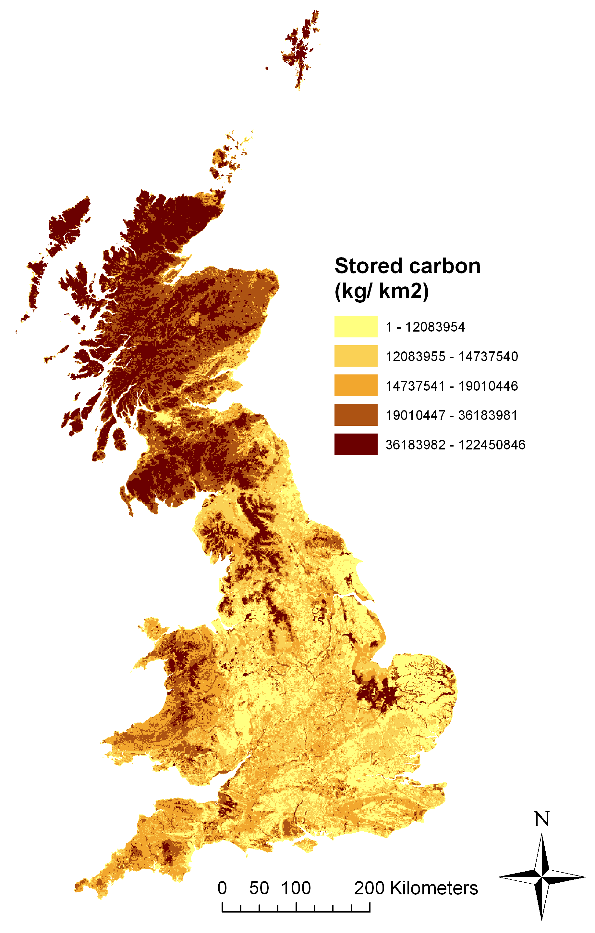
Fig. S4 – Stored carbon at the 1 x 1 km grid resolution.
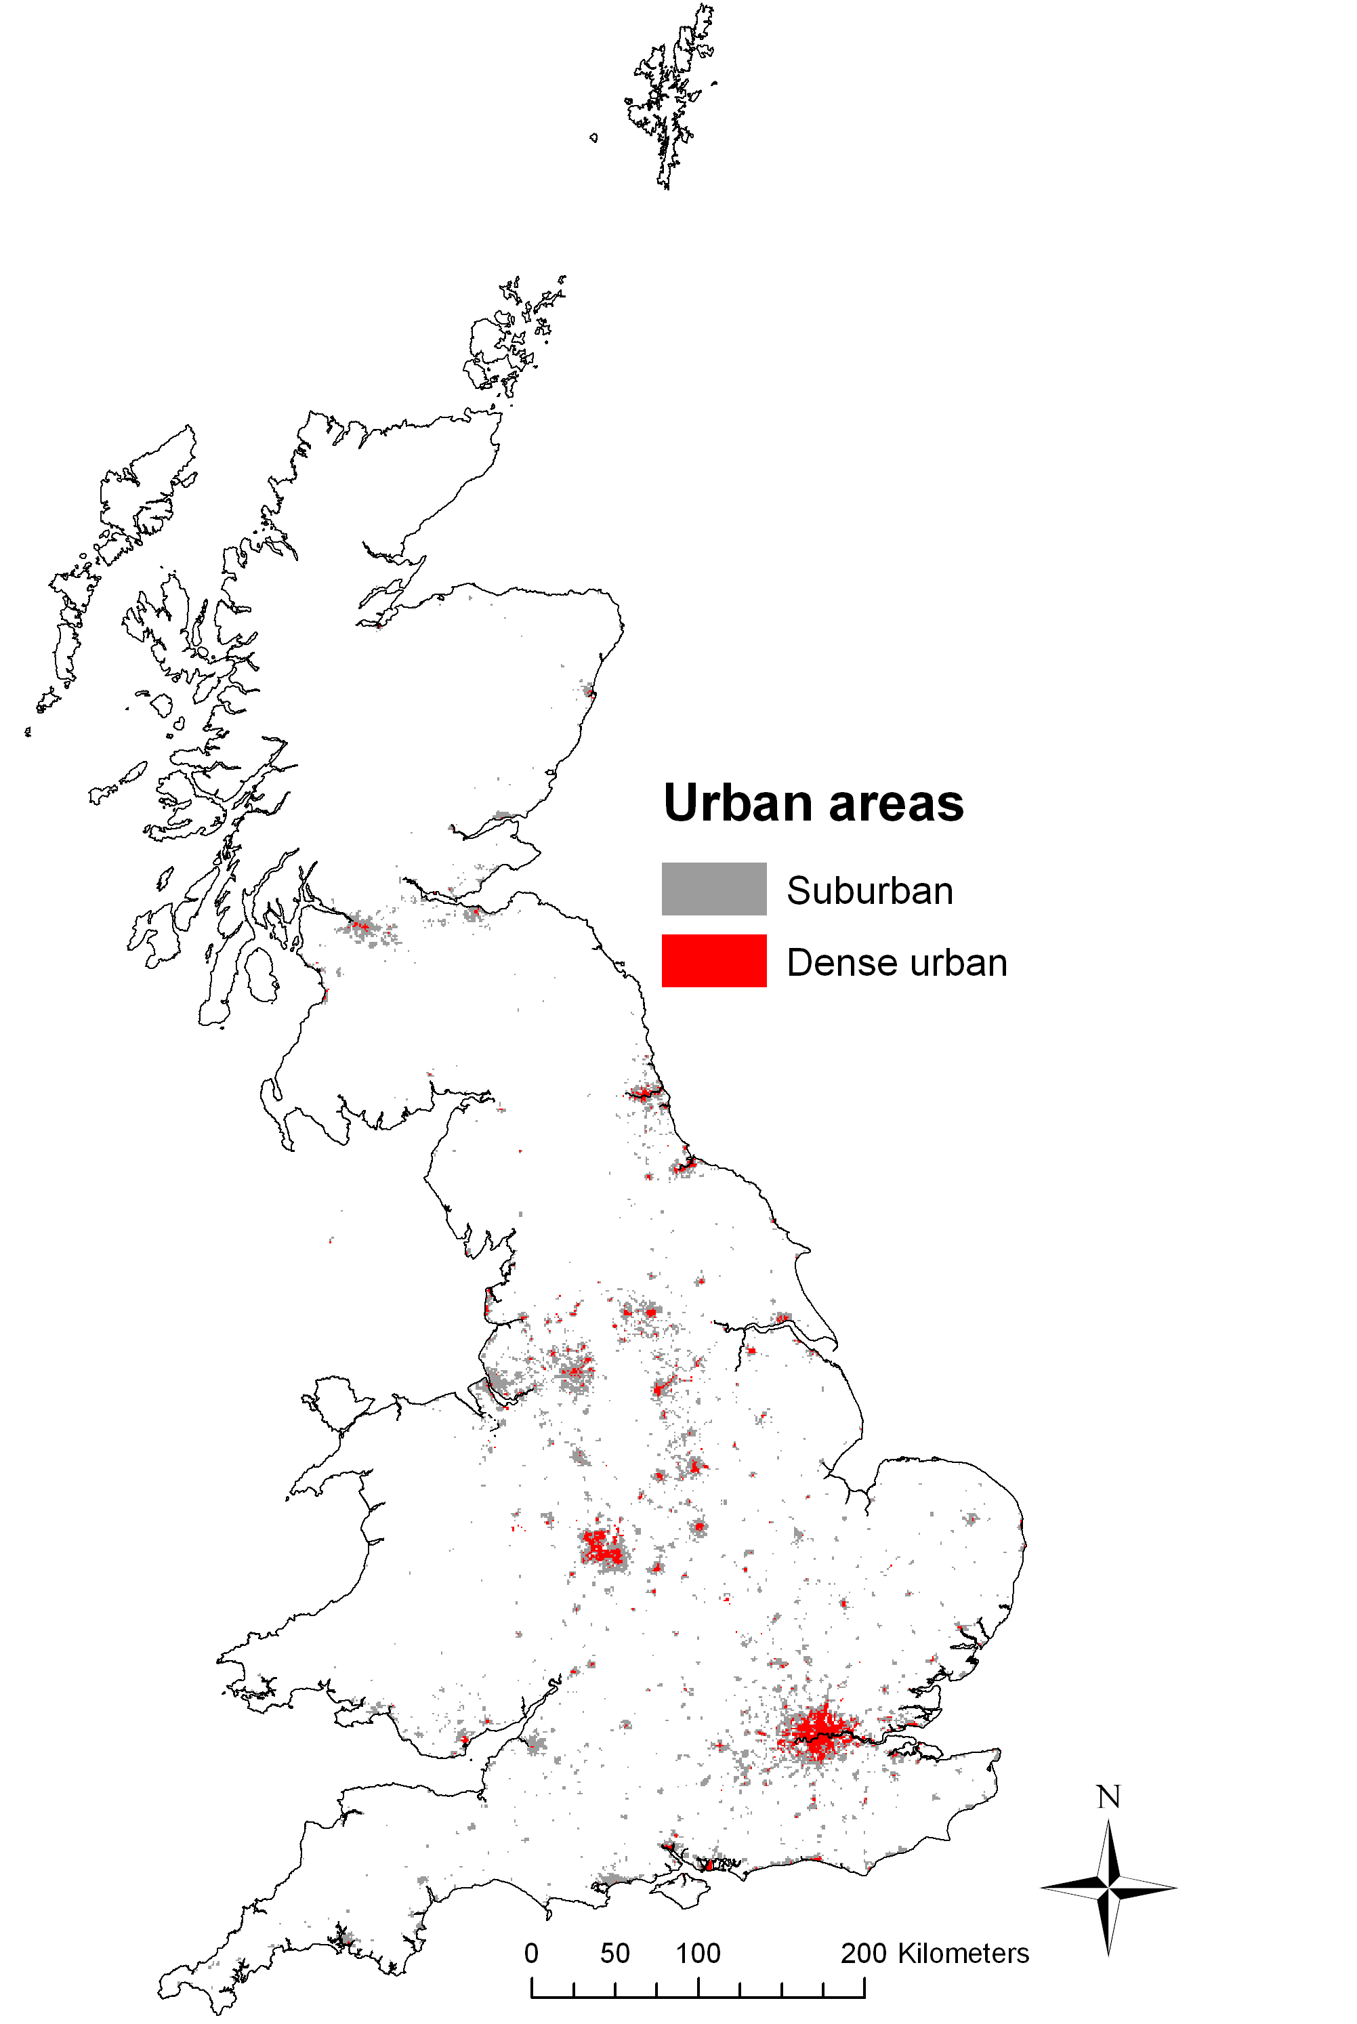
Fig. S5 – Current dense urban and suburban land cover at the 1 x 1 km grid resolution. Majority weighting is used; that is cells are only considered dense urban or suburban if at least 50% of the land area of the grid cell is covered by this land cover type. Cells where the combination of dense urban and suburban land cover combine to over 50% of the grid square, but where neither sub-category covers 50% of the grid square, are considered to be suburban.

